**Abstract**:

Krishok is an IoT based farming solution for Bangladeshi farmers to grow better amount of crops with better quality. Another outcome of this project is to help the farmers to face any kind of unknown condition which they did not face in their farming life. The whole system is automated where the device will notify the the suggestions to the farmers by analysing the data which it will get from it’s sensors, cameras, learning, and analytical capability. It will open job opportunity with a minimum budget but maximum profit in reply. The opened job opportunity of the project will be for those people who have a little technical knowledge.

**Architecture** :

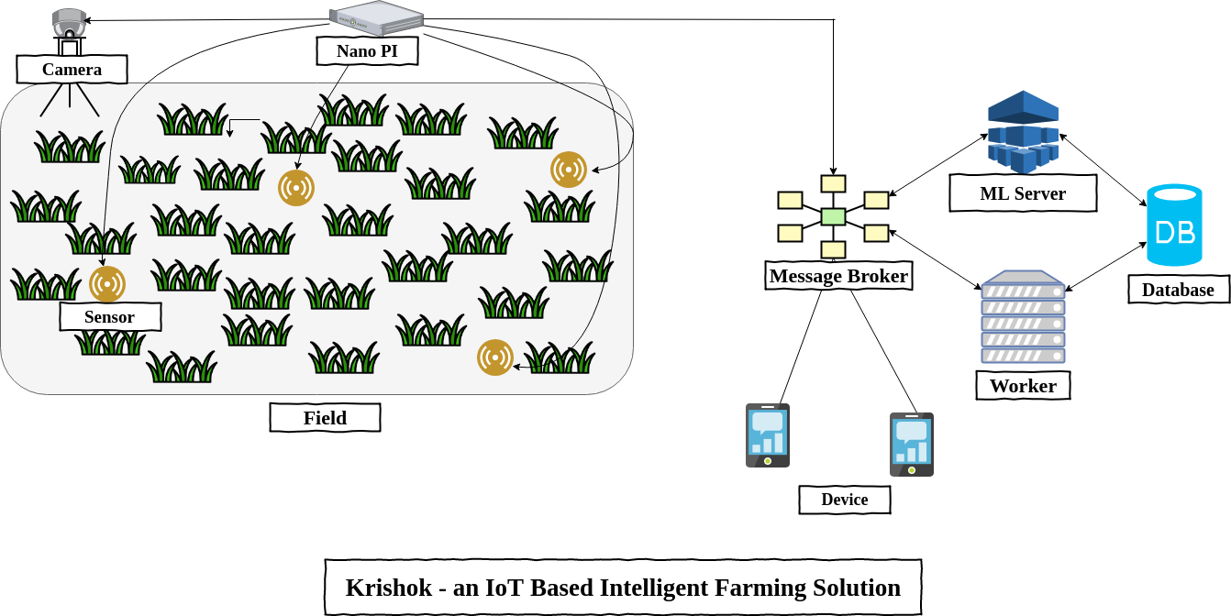

**Technologies for backend:**

Protocols : HTTP, MQTT

Frameworks: Spring Boot, Android  
Languages: Java

**Backend**:

The worker will get data from the Krishok device and it will process them to serve the ML server and Android app. The worker will be also responsible for sending notifications and warning to the device and Android app. The worker will communicate with the device using the MQTT protocol , ML server and the Android app will communicate using RESTful API.

# **Conclusion:**

Though the aim of our project is to give a bit pace to our agricultural system, along with it, the project will open the job opportunity for the people who have a little training on technical site. So, the project has two types of economical and technical advancement which will eventually lead the agricultural system to opt for more advance technology.